SEEMA GOEL – MAWA ARTIST TEACHER GROUP PRESENTATION May 1st

Critiques serve two purposes: evaluation and feedback. We are interested in giving each other thoughtful feedback:
- Be a good listener when your art is being discussed.
- “Taste, is not necessary to lead us” (Seema). When giving feedback: avoid expressing your 'taste' ie I like / dislike / pleasure…
- Be cognizant of the time when you are being critiqued.

Materials used in work of art are a good place to start the critique:
- Why are we using certain types of materials to make our art?
- Materials have meaning; they are very important. Materials hold meaning in and of themselves. This is a good place to begin a critique discussion.
- This gives us permission to use a wide variety of materials to create with.
- Why am I choosing these materials? Understand why.
- What is missing? That is as important as what is there.
- Take something we know so well and transform it [ie Karin Sander’s Polished Chicken Egg].

Titles: a way of helping the viewers engage in the artwork.
- Titles are “Points of entry.”
- Titles and artist statement add richness to the piece.
- People go to art shows and take home the work they can connect with, that may draw them back to another time and place.
- Use the opportunity of titling art, not to explain it away, but to give the viewer a chance to connect. It’s an entry point, a great start.
- Viewers come to the art because they’re already engaged with what they see, the title [and the artist statement] give them more.

Artist Statements: another point of entry.
- Do not have to be super didactic.
- Don't give it all away. Not a biography.
- We can derail our work by telling too much. Be careful about putting your diary out on display.
- Think about: how personal can I be without putting my feelings out for critique?
- Personal work is potent, but dangerous and it’s not necessary to share everything.
- We must be past the diary stage before we share. Push past the personal realm to connect with others.
- Our feeling should never be up for critique.
- Our work doesn’t have to be for the world, some things are for our own personal journey.
- “Art is about exposing wounds, not about healing” (advice from an artist talk Seema attended in Grad School).
- "The success of the work is in its ability to communicate something. … The ability of ‘thing’ to communicate is important” (Seema Goel).

Find concept: it doesn’t have to be about self personally. Start with observing:
- What distracts you?
- What do you obsess about?

What is art? Discussed the change in society’s understanding of what is Art. At one time anything made of bronze or with oil paint was art. Black velvet paintings were not art, but now they can be. Materials themselves have meaning. Today, there’s a freer way to work with materials. The line between kitsch and Art is dissolving. Kitsch, culture and Art interplay. Glass pushpins can be art.

Artist discussed: Karin Sander, polished egg, ordinary to extraordinary. Without knowing any more about the orb in the photo below, except for the name “Polished Chicken Egg,” the group discussed the object: fragility, ubiquitous, pre-fetus, related to birth/life, food, marble, universal, light/shadow, 3 dimensional sphere study, precarious, treasure, “ordinariness.”
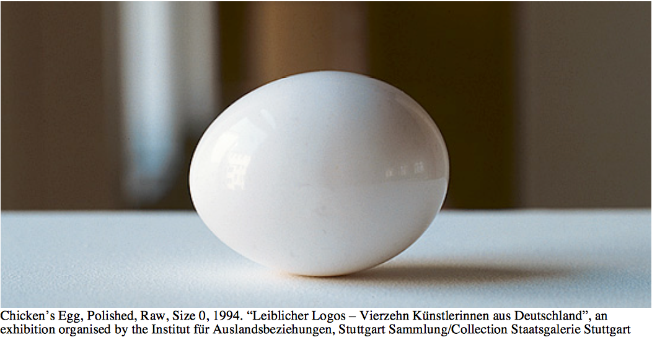
Image Source: Harald Welzer and Karin Sander: On Making Things Visible
A Conversation http://www.mit.edu/~allanmc/Karin%20Sander-Interview-images.pdf
=====

De-familiarization: Take something we think we know so well and completely transform it – this could be materials or subject.

Other notes (interesting considerations):

Old world paintings have a narrative. They talk about trade routes, culture, the preciousness of flowers and fruit gained from other countries and overseas. In the Dutch Golden Age there are many popular paintings with brilliantly coloured tulips, but tulips were not from Holland, they originated in Turkey.

Today we may not make this link about the value those flowers in paintings held and what was embedded in the story of their arrival and esteemed place they held in Holland’s identity. In fact, the flowers were traded, and bulbs so valued they were used as money. If the artist had written an artist statement we’d know that history now. Similarly, the European, still life, oil paintings of the rind being cut from the yellow lemon next to the sterling silver and crystal is meant to convey the lemon’s preciousness during that era. This South American treat was so treasured that nothing could be wasted and the rind kept to be candied. If we don’t have an artist statement we miss an opportunity to connect with the viewer; to relay context, to relay the artist’s connection to the subject matter or concept.

NOTES PROVIDED BY Cheryl Zubrack & Lois Friesen, Edited by Seema Goel

